MODULE 3

|  |  |
| --- | --- |
| Taxonomy | Ontologies |
| A taxonomy is a representation of the formal structure of classes or types of objects  within a domain. | An ontology provides more detail than a taxonomy |
| Taxonomies are generally hierarchical and provide names for each  class in the domain. | Although the boundary between Taxonomy and Ontologies is somewhat fuzzy. |
| They may also capture the membership properties of each object  in relation to the other objects. | An ontology should capture the common  understanding—vocabulary, definitions, and rules—of a community as it applies to a specific domain. |

Ex:

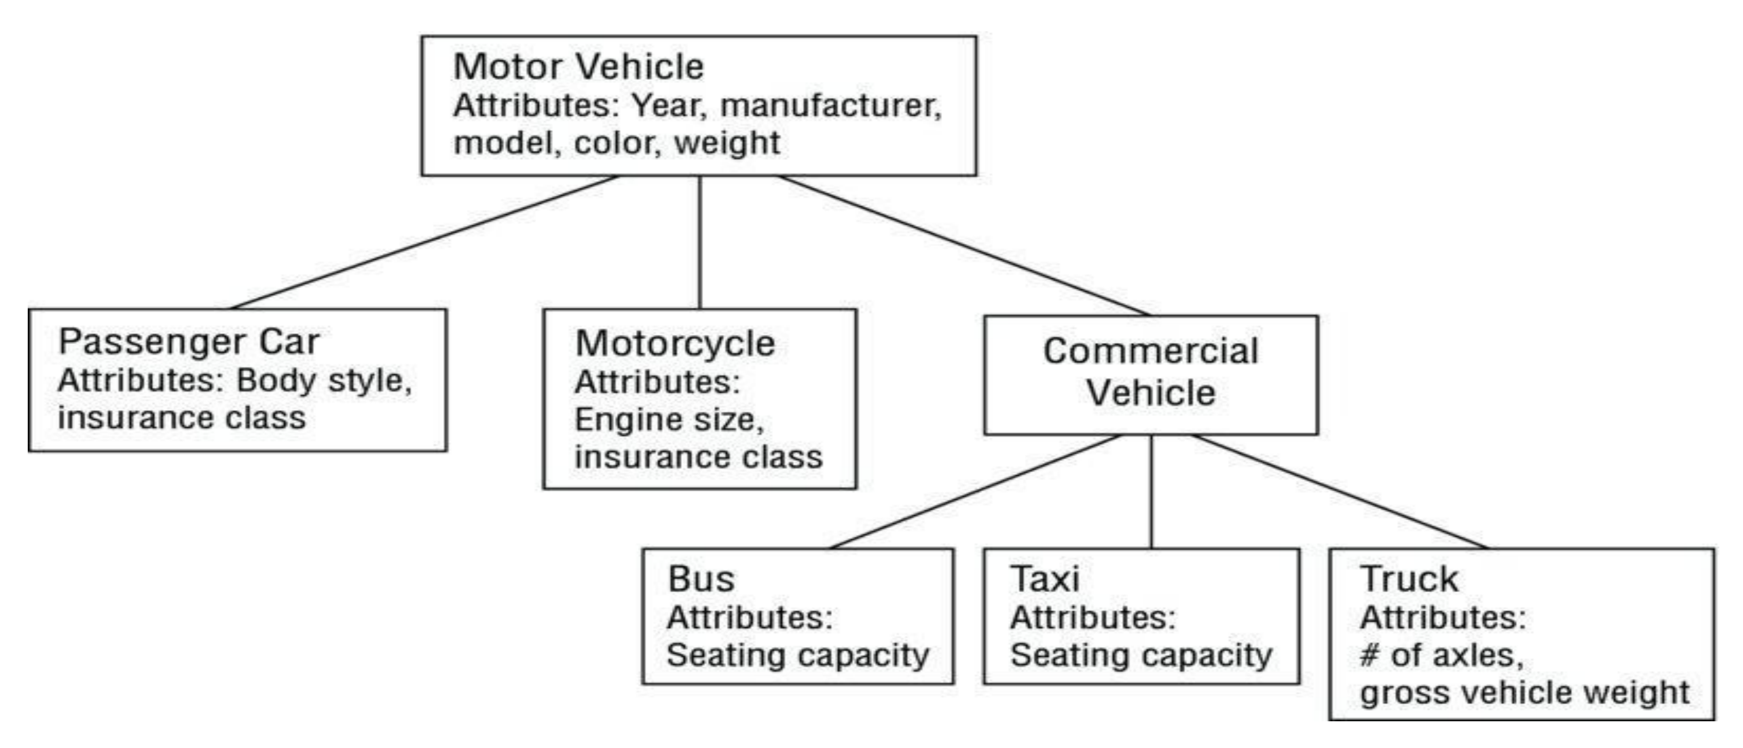

Knowledge Representation:-

Knowledge representation in cognitive computing include facts or beliefs, general information, standard knowledge organizational structures such as ontologies and taxonomies, and relationships, rules, or properties that describe and categorize objects.

How to represent Knowledge?

* Domain knowledge within a cognitive computing application may be captured and stored in a variety of data structures, from simple lists, to conventional databases, to documents, to multidimensional purpose-built structures.
* Cognitive computing system designers can use procedural, list-processing, functional, or object-oriented programming languages to specify and implement these structures.
* They may use data modeling tools or even specify the knowledge model in a language ,created just for representation purpose.
* The choice of tools and representations should reflect the types of operations the system will have
* to perform on the data.

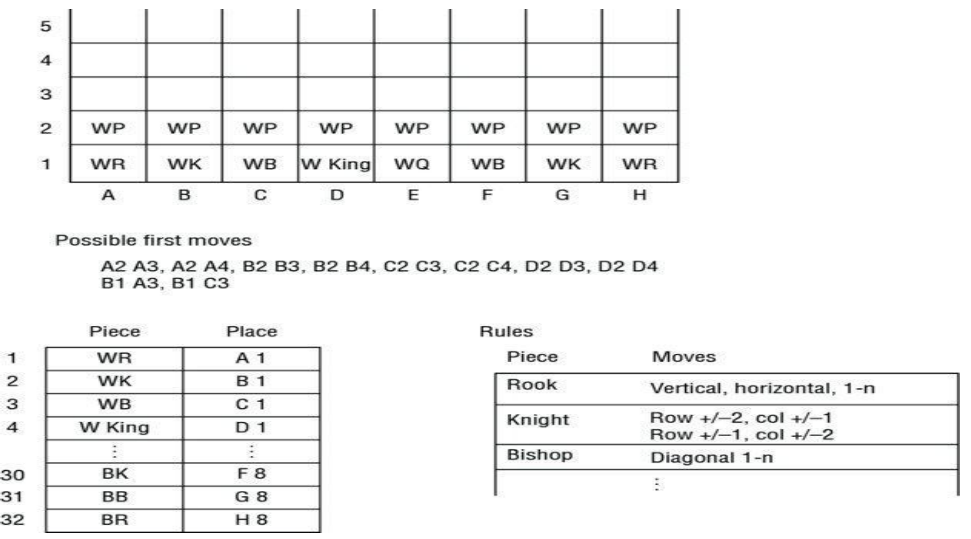

Models used for Knowledge Representation: -

Taxonomy

Ontologies

Simple Trees

Semantic Web

|  |  |
| --- | --- |
| Simple Trees | Semantic Web |
| A simple tree is a logical data structure that captures parent-child relationships. | A semantic network is a graphical representation of knowledge in which concepts are represented as nodes and the relationships between them are represented as links. |
| Simple trees are used frequently in data analytic tools and in catalogs. | Semantic Webare used frequently in data integration. |
| For example, a retailer’s catalog may have 30 or 40 categories of products that it offers. Each category would have a series of elements that are members of that category. | For example, a semantic  network could represent the relationships between different animals, with nodes representing animals and links representing  relationships like "predator of" or "prey of". |
|  |  |

|  |  |
| --- | --- |
| Syntax | Semantics |
| Process of analyzing a string or symbols either in Natural Language, Computer Language or Data Structures conforming to the rules of grammar | Process to cheque whether the generated parse tree is according to the rules of programming language. |
| Parser perform syntax analysis | Semantic analyzer perform semantic analysis |
| Second phase is the compilation phase | Third phase is the compilation phase |
| Generates a parse tree | Generates a annotated tree |

Role of NLP in a cognitive system:

* NLP is a set of techniques that extract meaning from text.
* These techniques determine the meaning of a word, phrase, sentence, or document by recognizing the grammatical rules—the predictable patterns within a language.
* They rely, as people do, on dictionaries, repeated patterns of co-occurring words, and other contextual clues to determine what the meaning might be.
* NLP applies the same known rules and patterns to make inferences about meaning in a text document.
* Translating unstructured content from a corpus of information into a meaningful knowledge base is the task of NLP.
* Linguistic analysis breaks down the text to provide meaning.
* The text has to be transformed so that the user can ask questions and get meaningful answers from the knowledge.